VIDYAVARDHAKA COLLEGE OF ENGINEERING
Autonomous Institute, Affiliated to Visvesvaraya Technological University, Belagavi
Gokulam, 3rd Stage, Mysuru 570 002
Sixth Semester BE Examinations
COURSE NAME: MACHINE LEARNING
Duration: 3 hours Max. Marks: 100
INSTRUCTION TO STUDENTS
- Answer One Full question from each module.
- Three module questions are compulsory and the remaining two modules will have internal choice.
- Each module carries 20 marks.
Q.  No. | Module-I | Marks | BL | CO
1. (a) | Discuss different types of machine learning with an example. | 10 | L2 | CO1
1. (b) | Analyze the following scenarios w.r.t implementation of machine learning algorithms and answer the following questions-  i) Recommend suitable machine learning techniques (supervised, unsupervised and reinforcement learning algorithm)  ii) Justify and state the process briefly on how to implement the machine learning technique for the task  Scenario-1  Students attend classes in which cameras are installed, students’ attendance for each class is recorded through the camera by capturing their faces. The faculty in charge for the class uses an automated interface to capture image of the class to report the attendance.  Scenario-2  Assume you want to purchase an exquisite gift item for your friend’s birthday. The gift item is only available in one of the stores in the city. You don’t know where the stores are located in the city. The birthday is 4 days ahead from now. Customers who visit stores are entertained by the store owners. | 10 | L4 | CO3
Module-II
2.(a) | Explain the process of multi-class classification with a suitable example | 10 | L2 | CO1
2.(b) | Illustrate the process of Optimal Separating Hyperplane for a binary classification problem | 10 | L3 | CO2
Module-III
3.(a) | Discuss the appropriate problems for learning neural network. | 10 | L2 | CO1
3.(b) | Illustrate back propagation algorithm using stochastic gradient descent method. | 10 | L3 | CO2
OR
4.(a) | Explain the appropriate problems for neural network learning | 10 | L2 | CO1
4.(b) | Design a two-input perceptron that implements the following Boolean function (A ^ B) by considering w1=1.2, w2=0.6, threshold=1 and learning rate = 0.5. | 10 | L3 | CO2
Module-IV
5.(a) | Consider the car theft problem with attributes Color, Type, Origin, and the target, Stolen can be either Yes or No. Estimate the conditional probabilities values for the instance {Color=Red, Type=SUV, Origin = Domestic}  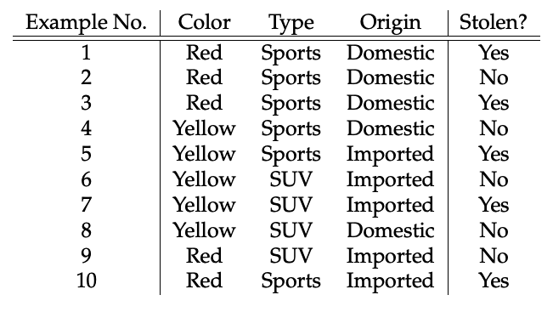 | 10 | L3 | CO2
5.(b) | Analyze Minimum Description Length Principle for choosing hypothesis to minimize sum of two description lengths. | 10 | L4 | CO3
OR
6.(a) | Illustrate Bayes Theorem and calculate the probability of a dangerous Fire when there is Smoke, Given:  - Dangerous fires are rate (1%)  - Smoke is fairly common (10%) due to barbecues  - 90% of dangerous fires make smoke | 10 | L3 | CO2
6.(b) | Prove, how maximum likelihood (Bayesian Learning) can be used in any learning algorithms that are used to minimize the squared error between actual output hypothesis and predicted output hypothesis. | 10 | L4 | CO3
Module-V
7.(a) | Explain the learning mechanism in Reinforcement Learning with a neat diagram. | 10 | L2 | CO1
7.(b) | Demonstrate the usage of K nearest neighbor classifier to predict the diabetic patient with the given features BMI and Age.  Assume K=3, for the given test example BMI=43.6, Age=40, Sugar =? Refer to Table 1.  Table 1: Diabetic patient  BMI Age Sugar  33.6 50 1  26.6 30 0  23.4 40 0  43.1 67 0  35.3 23 1  35.9 67 1  36.7 45 1  25.7 46 0  23.3 29 0  31 56 1 | 10 | L3 | CO2



